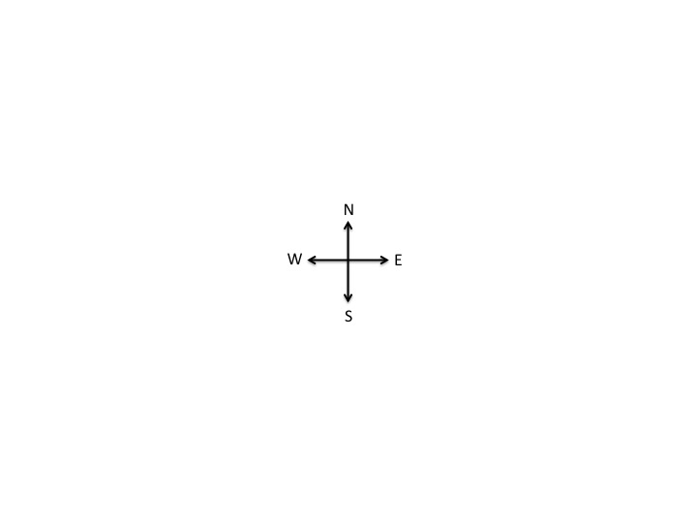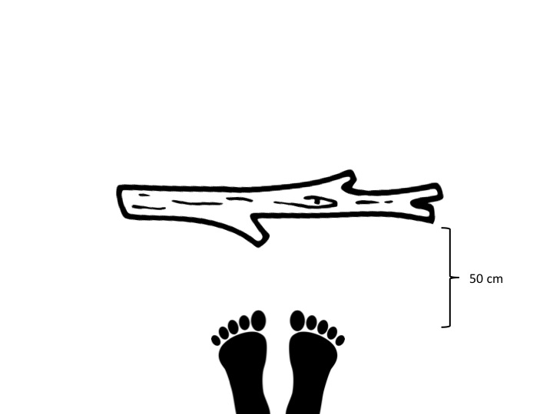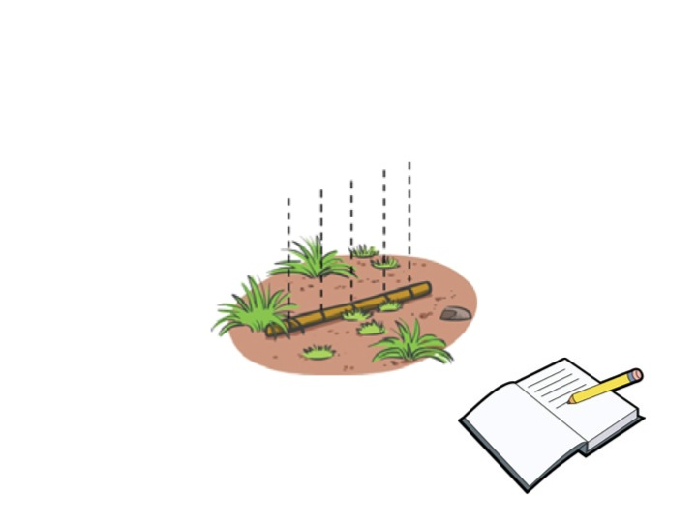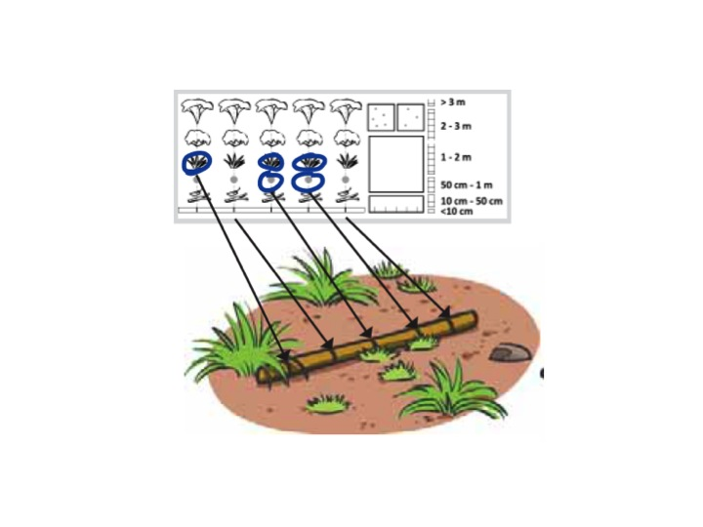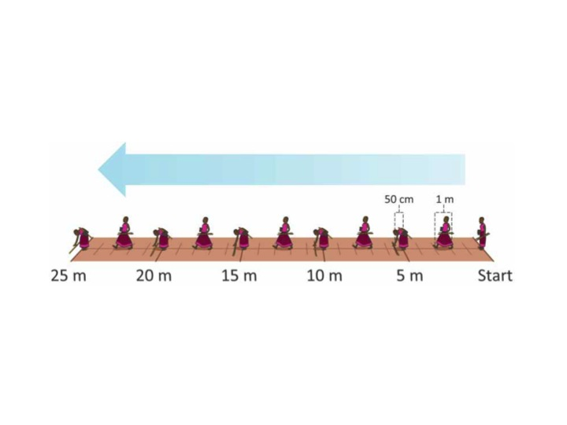

Lines will appear on each of the tick marks that appear on the stick. The notebook appears.

FADE TO: The person drops the stick at the 5 m mark, 50 cm away from his feet.

Open to cross. Slowly move the cross in one direction and a person walks in one direction. Perhaps the 0-25 m line from “Walking a Transect” will appear and disappear.

FADE IN: the page in the notebook becomes visible showing the observations made at the site.

FADE TO: a rapid visual of the entire walking process will appear so the user can see the entire process.